**Welcome to the official website of Matamba Lukasu .**

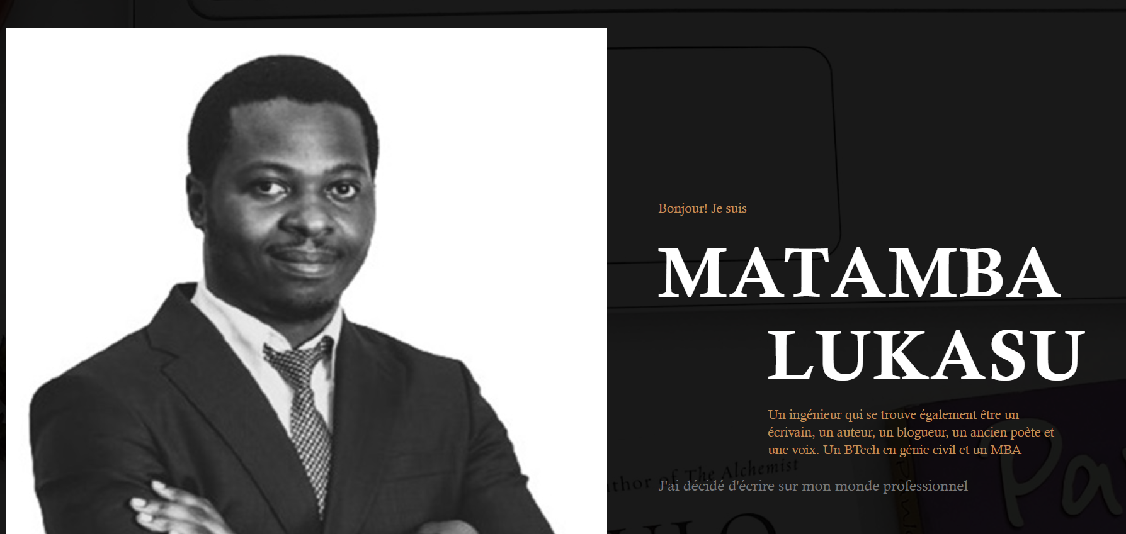

This site is dedicated to the literary work of the writer but also to the reflections of the patriot. Authors of several books including "To you who are not like me, 2012" and "In Search of a lost me, 2017", Matamba Lukasu returns to us in 2025 with " Africanie " subtitled This is how I became head of state. **Africanie** is an incisive and critical account of dictatorial regimes that arise from rebellions, with the support of Western powers. These regimes continue to keep Africa in a cycle of violence and repression where thousands of children and women find themselves held hostage to this day. The author depicts with brutal intensity the reality experienced by millions of people across the continent, bluntly exposing the suffering inflicted by these autocratic regimes. Through scenes of raw violence, he reveals the devastating consequences of this collusion between African dictators and foreign interests.

This book tells the story of a child soldier forged by war who became president. Trained in an environment of terror and incessant conflict, this man knew only the language of violence to survive. Growing up in the depths of chaos, he reproduces this same brutality once in power, unable to imagine any other way of governing than through war and vengeance.

In **Africanie** , the author offers us a profound reflection on the devastating impact of authoritarian regimes and on the way in which violence shapes not only men, but also nations. This book highlights the complexity of the African political situation, where injustice, war and foreign manipulation combine to perpetuate untold suffering.

A powerful testimony to the need to break this vicious cycle, Africanie is a call to rethink Africa's future, to reject violence as a mode of governance, and to imagine a continent where justice, peace, and human dignity triumph.

ABOUT THE AUTHOR ( ~~ABOUT ME~~ )

Matamba Lukasu is a deeply committed author, placing Africa and its realities at the heart of his writings. Author of books such as **À toi qui n'es pas comme moi** and **À la recherche d'un moi perdu** , as well as several professional publications, he is distinguished by an approach that often challenges his readership in a provocative manner. His goal is to awaken collective consciousness on the real issues of African development. Through his stories, he bluntly exposes the errors of governments and the abuses of multinationals, while seeking to provoke awareness and collective action for a better future.

His work Africanie , of which Voici comment je suis devenu chef d'État is only the beginning, presents itself as an open chronicle, leaving the door to other books that will explore this theme further. This series could continue to deal with the contemporary challenges of Africa, by highlighting the political, economic, and social dynamics of the continent. Africanie is also a door ajar on the awakening of an Africa freed from its old demons.

Through this approach, Matamba Lukasu seeks to push the thinking on African development even further, by constantly challenging his readership on the issues that will shape the future of the continent. The author hopes to play a crucial role in the emergence of authentic African voices that aspire to real change.

~~Look at me~~

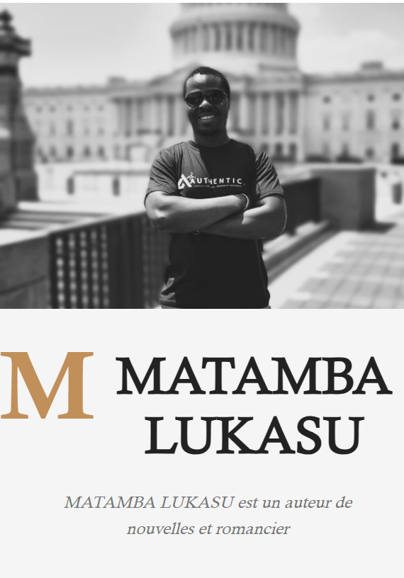

**Discover the world of Matamba Lukasu visiting the blog** ( add link to the blog). Keep the big Matamba Lukasu but replace the phrase underneath by the phrase in bold.